1.. | Find the area of the following shapes  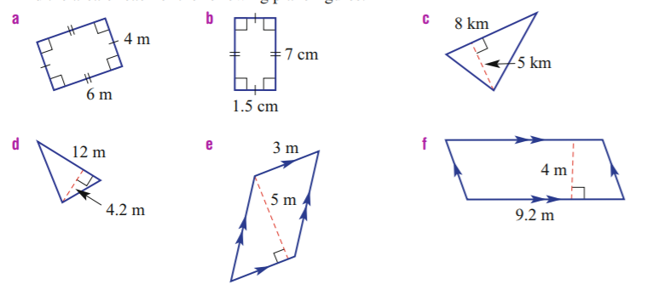 | 2. | Find the area of the following shapes  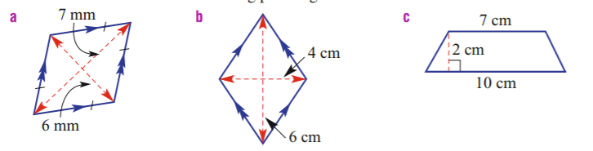
3. | 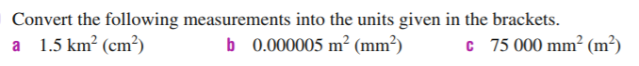

1.. | Find the area of the following shapes   | 2. | Find the area of the following shapes  
3. | 

